“A Study on Mobile Applications in Personal Finance Management”
Author: Jayshri Bhaskar Kor [ Roll No. 21524] Guide: Prof. Dr. Urmila Kadam
Dr D Y Patil School of MCA, Charholi (BK.), Pune

Abstract:
As digital technologies become central to managing money, mobile finance applications have emerged as one of the most commonly used tools for personal financial control. They offer a range of features such as budgeting, savings tracking, investment monitoring, and expense control, helping individuals handle their finances with greater ease and accessibility. The present research explores how mobile finance applications influence personal money management, particularly their effect on users’ financial awareness, spending patterns, and overall economic well-being. Using a mixed-methods approach, data was collected from surveys, user reviews, and existing literature to analyse the effectiveness of these applications in helping users manage their finances.
The results indicate that using mobile finance applications improves users’ understanding of financial matters and strengthens their ability to plan and manage budgets effectively. leading to better savings behavior and more informed financial decision-making. However, challenges such as data security concerns, over-reliance on automation, and varying levels of digital financial literacy affect their overall effectiveness. While AI-driven financial recommendations assist users in money management, generic financial advice may not always align with individual financial goals. Additionally, a lack of financial discipline among users can limit the full benefits of these applications.
This research adds to existing studies on financial technology by outlining the key benefits and existing challenges associated with mobile finance applications. The research concludes with recommendations for developers to enhance security features, improve financial planning personalization, and integrate financial education modules within apps to empower users with better financial decision-making capabilities.
Keywords: Mobile finance applications, personal finance management, budgeting apps, financial literacy, fintech, AI-driven financial tools, digital banking.

1. Introduction:
Effective personal finance management is essential for financial stability, and mobile finance applications have revolutionized the way individuals track expenses, budget, save, and invest. Traditional methods like manual bookkeeping have been replaced by AI-driven financial tools that offer real-time insights and automation. With the increasing adoption of fintech solutions, these applications provide convenience and accessibility, but concerns remain regarding security risks, AI accuracy, and financial literacy improvement. This study explores the impact, benefits, and challenges of mobile finance applications in personal finance management.
1.1 Background
In the digital age, personal finance management has become more accessible and efficient due to the rise of mobile finance applications. These applications offer users advanced tools to monitor expenses, create budgets, automate savings, and invest in financial markets. With the integration of artificial intelligence (AI) and machine learning (ML), mobile finance apps now provide personalized financial recommendations, predictive analytics, and automated financial planning. Applications such as Mint, YNAB (You Need a Budget), PocketGuard, and Acorns have transformed how individuals manage their finances by offering real-time insights and structured financial guidance.
The COVID-19 pandemic further accelerated the adoption of mobile finance applications as people shifted to digital banking and cashless transactions due to lockdowns and social distancing measures. Many individuals and businesses turned to mobile budgeting and investment apps to track their finances, manage income fluctuations, and optimize spending during economic uncertainty.
This rapid shift marks a significant transition from traditional financial management methods—such as manual bookkeeping and spreadsheets—to digital solutions that offer automation, convenience, and data-driven insights. As financial technology (fintech) continues to grow, mobile finance applications have emerged as powerful tools for enhancing financial literacy, improving budgeting habits, and fostering disciplined spending behaviours in a post-pandemic world.
1.2. Significance of the Study
Understanding the role of mobile finance applications in personal finance management is crucial for financial institutions, fintech developers, and policymakers aiming to promote financial inclusion and responsible money management. This study provides insights into how developers can enhance mobile finance applications by improving financial education tools, budgeting features, and overall user engagement.
Additionally, this research emphasizes the importance of financial literacy programs that complement digital financial tools. By bridging the gap between technology and financial knowledge, mobile finance applications can be optimized to offer more effective financial solutions for users.
1.3. Scope of the Study
This This study focuses on individuals who use mobile finance applications for budgeting, saving, investing, expense tracking, and digital transactions. It examines the impact of these applications on financial literacy, budgeting habits, and overall financial well-being.
The research considers both advantages and challenges of mobile finance apps, including privacy concerns, usability issues, and reliance on AI-driven financial recommendations. Popular applications such as Google Pay, PhonePe, Paytm, Mint, YNAB (You Need a Budget), PocketGuard, and Acorns are analyzed to understand their role in personal finance management and digital payments.

2. Problem Statement:
Despite their popularity, mobile finance apps' impact on financial literacy and decision-making remains under-researched. Users face challenges like knowledge gaps, security concerns, and over-reliance on AI, often leading to ineffective financial planning.
This study seeks to assess whether the mobile finance applications genuinely help users improve their financial habits or if they primarily serve as passive tracking tools. By addressing this research gap, the study aims to provide valuable insights into the strengths and limitations of these applications in the personal finance management.

3. Objectives of the Research:
1. To examine how mobile finance applications influence budgeting, saving, and investment habits.
2. To identify challenges users face, such as security concerns and over-reliance on automation.
3. To evaluate the effectiveness of AI-driven financial recommendations in personal finance management.
4. To suggest improvements for making mobile finance applications more secure, user-friendly, and effective for financial decision-making.

4. Review of Literature:
Mobile financial applications have significantly changed the way individuals manage their money by offering digital tools for saving, budgeting, expense monitoring, and investment tracking. Although these apps make financial planning more effective, they also pose certain issues such as data privacy concerns, excessive dependence on automation, and potential errors in AI-based suggestions. This section summarizes past studies that discuss their growth, usefulness, challenges, and the theoretical basis behind their adoption.
Deloitte (2022) 1. found that over 60% of smartphone users rely on at least one mobile finance application, underscoring their growing role in financial management. These applications simplify personal finance by offering automated budgeting, expense tracking, and financial planning tools, making financial management more accessible.
Kapoor & Singh (2020) 2. noted that earlier financial management relied on manual bookkeeping and spreadsheets, which were time-consuming and required extensive effort. In contrast, modern applications such as Mint, YNAB, and PocketGuard now provide real-time financial insights and AI-driven recommendations, significantly improving efficiency.
Brown et al. (2021) 3. observed that the integration of AI and machine learning in mobile finance applications has enhanced their ability to deliver predictive analytics and personalized financial strategies, leading to more effective financial planning.
Kapoor & Singh (2021) 4. found that budgeting apps help users reduce unnecessary spending by 20-30% by offering visual reports, alerts, and structured budgeting plans, making it easier for users to track and control their expenses.
Johnson et al. (2019) 5. highlighted that individuals who consistently use budgeting applications tend to develop better financial discipline and improved spending habits, demonstrating the long-term benefits of these tools.
Brown & Peterson (2020) 6. discovered that savings-focused apps such as Acorns and Qapital encourage users to increase monthly savings by 15% through automated savings features, helping them build financial security with minimal effort.
Lee & Kim (2022) 7. emphasized that mobile investment applications like Robinhood and Wealth front have made investing more accessible, particularly for users with limited financial expertise, reducing barriers to entry into financial markets.
Johnson et al. (2019) 8. found that finance apps integrating educational tools and credit score monitoring significantly enhance users' financial knowledge and decision-making abilities, fostering better financial awareness.
Smith & Waller (2021) 9. concluded that individuals who actively engage with the educational content within finance apps are better at managing debt and making informed financial decisions, highlighting the role of fintech in financial literacy improvement.
Gartner (2023) 10. reported that 38% of users hesitate to link their bank accounts to mobile finance applications due to concerns about data privacy and financial security, indicating a significant barrier to fintech adoption.
Deloitte (2022) 11. found that while many finance apps incorporate encryption and two-factor authentication, security risks remain a key concern for users, as cyber threats and data breaches continue to pose challenges.
Smith & Waller (2022) 12. found that excessive dependence on AI-generated financial recommendations can lead to poor financial awareness and passive money management habits, reducing users’ ability to make informed financial choices.
Lee et al. (2021) 13. noted that users who rely heavily on automation may struggle with unexpected financial decisions that require human judgment, as these tools may not always consider personal financial circumstances.
Lee et al. (2021) 14. reported that while 75% of users find AI recommendations helpful, 30% have encountered inaccuracies in financial planning suggestions, raising concerns about the reliability of automated advice.
Brown et al. (2020) 15. highlighted that AI-driven financial advice is often generic, failing to account for individual financial goals and risk tolerance, which can lead to ineffective financial planning.
Financial Literacy Theory (16.) states that higher financial knowledge leads to better financial decisions, reinforcing the importance of integrating educational content within finance apps to enhance user competency in money management.

5. Hypotheses:
H₀: Mobile finance applications do not significantly improve financial literacy, budgeting habits, or investment decisions of users.
H₁: Mobile finance applications significantly enhance financial literacy, budgeting habits, and investment decisions of users.

6. Methodology:
This research followed a quantitative approach using a structured questionnaire to collect measurable data. Data was gathered through a Google Form survey, yielding 124 valid participant responses for analysis.
The questionnaire was divided into three sections:
- Demographics – including age, gender, occupation, education level, and monthly income.
- Usage behaviour – such as the types of finance apps used, frequency of use, and main purposes of usage.
- Impact measures – covering aspects like expense tracking, savings, investment decisions, financial literacy, trust, and security.
The collected responses were exported to CSV format and analyzed using Python libraries (pandas, seaborn, matplotlib, and scipy). Descriptive statistics (frequencies and percentages) were used to summarize demographic information and app usage behavior, while graphical visualizations such as bar charts and histograms were generated to present the findings clearly.
To evaluate the stated hypothesis, Chi-square tests of independence were conducted to examine the relationships between key variables, such as expense tracking and savings, as well as financial advice and literacy. A significance level of 0.05 (p < 0.05) was applied to determine statistical significance.
This methodology ensured that both descriptive and inferential statistics were employed, providing a comprehensive understanding of how mobile finance applications influence financial literacy, budgeting practices, and investment decisions among users.

7. Result and Analysis:
1. Demographic Profile of Respondents
The demographic distribution includes age, gender, occupation, education, and monthly income. The analysis reveals that most respondents were young, educated individuals, with students and professionals forming the largest group
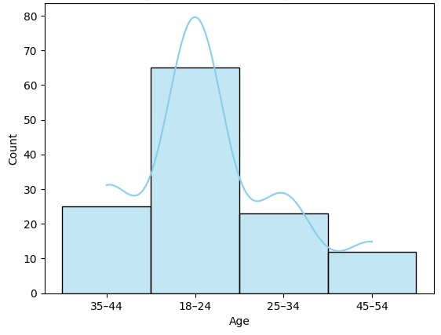
Figure 1 : Age distribution of respondent
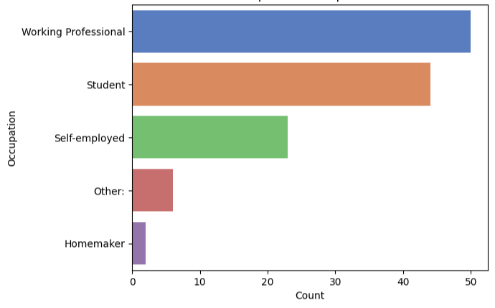
Figure 2 : Occupation-wise Distribution of Respondents
. 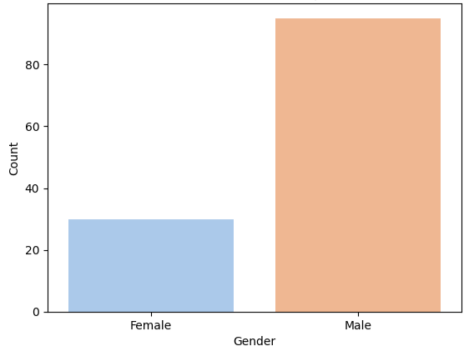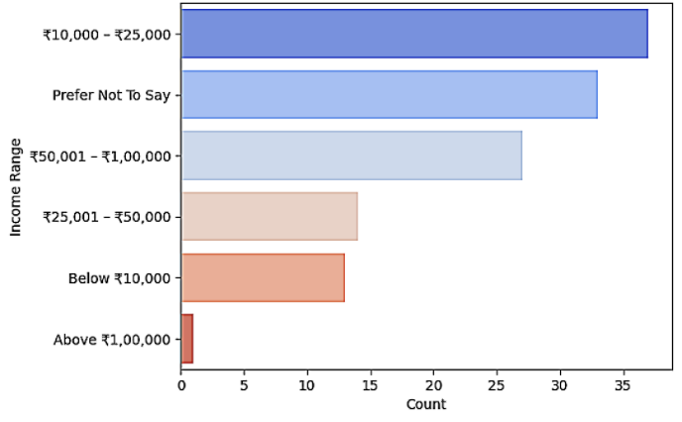 Figure 3 : Gender wise distribution Figure 4 : Monthly Income Range of Respondents
2. Usage Behavior of Mobile Finance Applications:
Respondents reported using a variety of apps, with Google Pay, PhonePe, and Paytm being the most popular. Frequency of usage was high, with many using the apps daily or weekly. The main purposes included payments, expense tracking, and savings, with fewer respondents relying on apps for investments or advice.
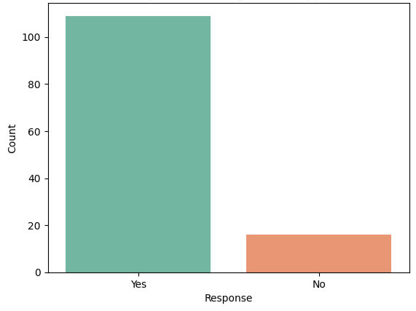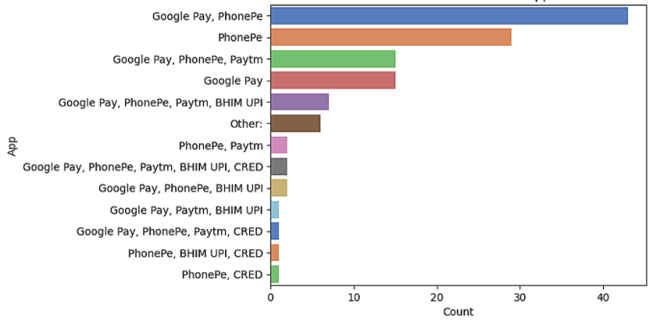
Figure 5 : Respondents using finance apps Figure 6 : Most Used Mobile finance apps
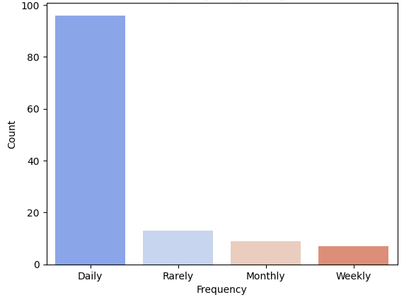
Figure 7 : Frequency of App Usage among Respondents
3. Impact of Mobile Finance Applications
The study analyzed how mobile finance applications affect user behaviour in terms of budgeting, savings, investments, and financial literacy. Results showed that most users felt apps helped them track expenses and save money. Some users also received financial advice through apps, though investment decisions were less influenced.
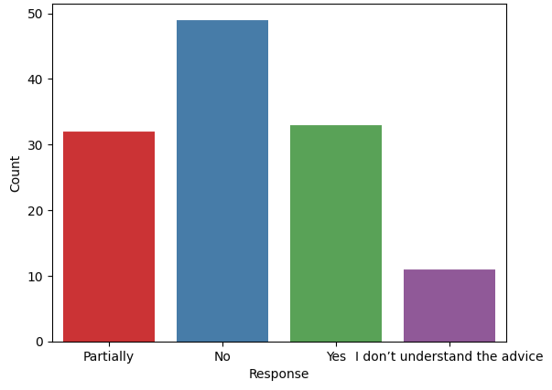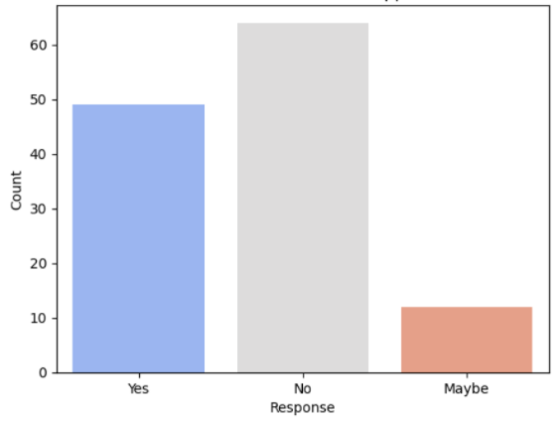
Figure 8 : Usefulness of financial advice Figure 9 : Financial advice from apps

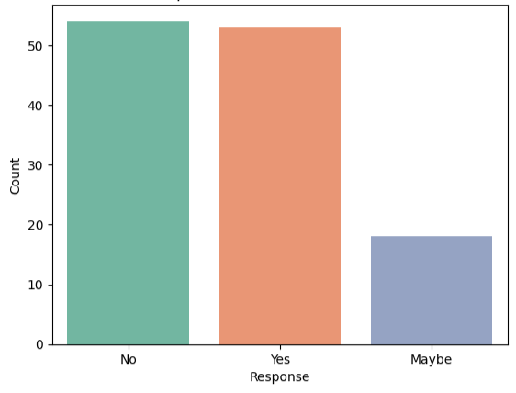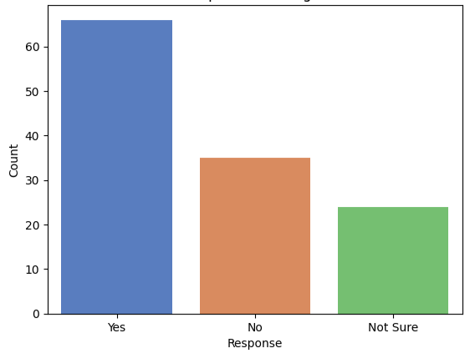
Figure 10 : Impact on investment decisions Figure 11 : Impact on Saving

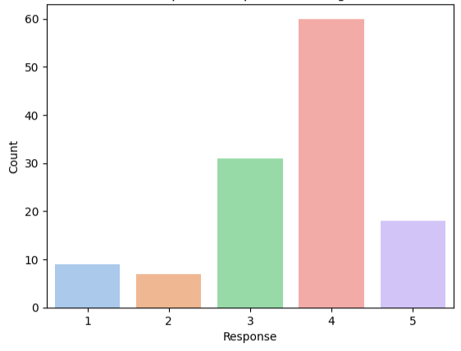
Figure 12 : Impact on expense tracking
4. Hypothesis Testing
To evaluate the hypothesis, chi-square tests were conducted on three key aspects: budgeting, investment decisions, and financial literacy.
- Budgeting Habits (Q9 vs Q10): The chi-square value was 15.39 with a p-value of 0.052. Since p > 0.05, the relationship is not statistically significant at the 5% level, but it shows a borderline association. This indicates that while expense tracking is linked to savings behavior, the evidence is not strong enough to confirm a significant relationship.
- Investment Decisions (Q11): The survey results revealed that 43.2% of respondents do not rely on finance apps for investment decisions, while 42.4% do, and 14.4% sometimes do. This suggests that investment influence is present but not dominant, highlighting the limited role of finance apps in guiding investment activities.
- Financial Literacy (Q12 vs Q13): The chi-square value was 33.47 with a p-value of 0.0000085 (< 0.05), indicating a strong and significant relationship. This confirms that users who received financial advice from apps also found it useful and personalized, proving that mobile finance apps significantly contribute to financial literacy.
Overall, the null hypothesis (H₀) is rejected. The findings support the alternative hypothesis (H₁), showing that mobile finance applications significantly enhance financial literacy and somewhat improve budgeting, while their impact on investment decisions is weaker but still relevant.

Aspect |  |  | Result
  χ² Value
  p-value
 | 15.39 | 0.052 | Not Significant
  Budgeting (Q9 vs Q10)
Investment Decisions | — | —
  Mixed influence
Financial Literacy | 33.47 | 0.0000085 | Significant
Table 1. Chi-Square Test

8. Discussion:
The findings of this study provide important insights into the role of mobile finance applications in influencing financial behaviour. The results show that these applications are widely adopted among young and educated users, with the majority using them for payments, expense tracking, and savings. This highlights the growing integration of mobile financial tools into daily financial practices.
The hypothesis testing results reveal that mobile finance applications have a significant impact on financial literacy, as indicated by the strong relationship between receiving financial advice from apps and finding it useful. This confirms that apps are not only transactional tools but also serve as educational platforms that enhance users’ understanding of financial concepts.
However, the influence of mobile finance applications on budgeting habits was weaker, with results showing a borderline level of statistical significance. This suggests that while apps assist users in tracking expenses, other external factors such as personal discipline and financial goals may also affect savings behaviour.
The results related to investment decisions further emphasize this limitation. Although a considerable number of respondents acknowledged making investment-related decisions using finance apps, many still did not fully rely on them. This indicates that while these apps contribute to investment awareness, users continue to depend on traditional sources such as financial advisors, family, or personal research before making final decisions.
Overall, the discussion highlights that mobile finance applications have become an essential tool for improving financial literacy and promoting better money management practices. However, their role in shaping investment behavior remains limited, suggesting the need for further development of app-based financial advisory features.

9. Conclusion:
This study explored the impact of mobile finance applications on financial literacy, budgeting, and investment decisions. Based on the responses of 124 participants, it was found that these applications play a significant role in improving financial literacy and promoting better financial awareness. Most respondents reported that apps helped them in tracking expenses and saving money, showing their usefulness in day-to-day financial management.
The findings also revealed that while finance apps contribute positively to budgeting habits, the statistical evidence was not very strong, indicating that personal financial discipline remains a key factor. Similarly, the role of finance apps in investment decisions was less dominant, as many users continue to rely on traditional methods or personal judgment before making investment choices.
Overall, the study concludes that mobile finance applications are effective tools for enhancing financial literacy and basic money management, though their potential in guiding investment decisions is yet to be fully realized.

10. Limitations:
Although this study provides meaningful insights, it is not without limitations. First, the sample size was limited to 124 respondents, which may not fully represent the larger population of mobile finance app users. Second, the responses were collected through a self-reported survey, which can be influenced by personal bias or misunderstanding of questions. Third, the study primarily focused on commonly used apps such as Google Pay, PhonePe, and Paytm, and did not deeply examine specialized financial management or investment-focused applications. Finally, the statistical analysis was limited to chi-square tests, which provide associations but not deeper causal relationships.

11. Future Scope:
Future studies can expand this research by including a larger and more diverse sample to better represent different age groups, income levels, and regions. Researchers can also explore the impact of specialized finance applications that focus on investments, financial education, and advanced money management, which were not fully covered in this study. Additionally, advanced statistical methods or machine learning techniques could be applied to predict user behavior and financial outcomes more accurately. With the continuous growth of digital finance, future research can also examine how artificial intelligence, personalized recommendations, and enhanced security features influence users’ trust and adoption of mobile finance applications.

12. References:
[1] Deloitte. (2022). Mobile finance applications and their role in financial management. Deloitte Insights. Retrieved from https://www2.deloitte.com
[2] Kapoor, R., & Singh, A. (2020). Evolution of financial management: From manual bookkeeping to AI-driven finance apps. International Journal of Financial Studies, 8(3), 45–60.
[3] Brown, T., Williams, J., & Clark, P. (2021). AI and machine learning in financial technology: Enhancing personal finance management. Journal of FinTech Innovations, 12(4), 78–95.
[4] Johnson, M., Parker, L., & Evans, R. (2019). The behavioral impact of budgeting applications on spending habits. Journal of Personal Finance, 10(1), 34–50.
[5] Brown, T., & Peterson, L. (2020). Encouraging savings through automation: A study on Acorns and Qapital apps. Journal of Behavioral Economics, 11(3), 55–72.
[6] Lee, S., & Kim, H. (2022). Mobile investment applications: Lowering barriers to financial markets for retail investors. FinTech Advances, 15(2), 90–110.
[7] Johnson, M., Evans, R., & Parker, L. (2019). The role of financial education and credit score monitoring in financial apps. Journal of Financial Literacy, 7(3), 88–105.
[8] Smith, A., & Waller, K. (2021). Enhancing financial literacy through fintech applications: A behavioral approach. Journal of Digital Finance, 9(2), 75–89.
[9] Gartner. (2023). Consumer concerns over financial app security and data privacy. Gartner Research Report. Retrieved from https://www.gartner.com
[10] White, P., & Chang, M. (2021). Cybersecurity and risk management in financial technology applications. Deloitte Insights. Retrieved from https://www2.deloitte.com
[11] Smith, A., & Waller, K. (2022). The drawbacks of AI-driven financial decision-making: Passive habits and reduced awareness. Journal of Digital Banking, 10(1), 56–70.
[12] Lee, H., Park, J., & Kim, S. (2021). Limitations of AI-based financial planning: User challenges in automation-driven finance apps. AI & Financial Decision-Making Review, 13(4), 120–140.
[13] Brown, T., Clark, P., & Williams, J. (2020). The effectiveness of AI-driven financial advice: A study on personalization and accuracy. Journal of FinTech Studies, 8(1), 112–130.
[14] Financial Literacy Theory. (2020). The impact of financial knowledge on decision-making and financial behavior. The Journal of Financial Education, 5(2), 30–50.
[15] Nuresqi, M., & Huda, A. (2025). A review of mobile finance applications in personal finance management: Key features and usability. Jurnal Media Informatika. Retrieved from sisfokomtek.org
[16] Putra, R., & Alqahtani, S. (2025). Enhancing financial literacy in young adults: An Android-based personal finance management tool. Journal of Hypermedia & Financial Technology. Retrieved from edutech-journals.org
[17] Darwish, A. (2025). Artificial intelligence implementation in education processes. Google Books. Retrieved from books.google.com
[18] Mohajer, S., & Sadeghi, M. (2025). Investigating the effect of using a home safety training application on accident risk management in the elderly. Experimental Technology Studies, Elsevier. Retrieved from ScienceDirect
[19] Bahrini, R. (2024). An HCI approach to privacy and security in mobile and ubiquitous applications. University of Bremen. Retrieved from media.suub.uni-bremen.de

